Mixed-Polygon Tessellation
# Source: AI Source: Provided by: [Data Path: Persons Table -> ID Column: 1, Name_En Column: Motasem Essam] -> From: [ChatGPT] on [7/25/2026]
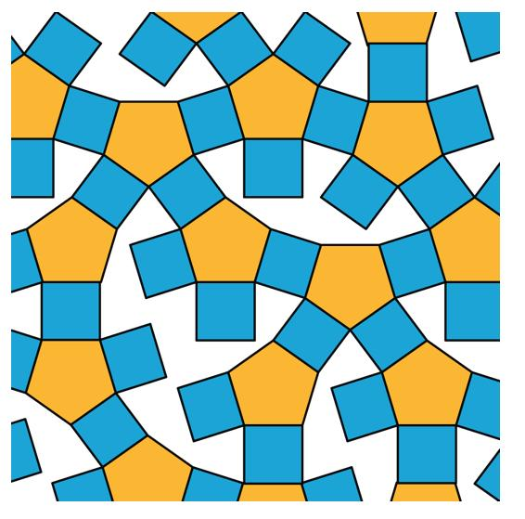
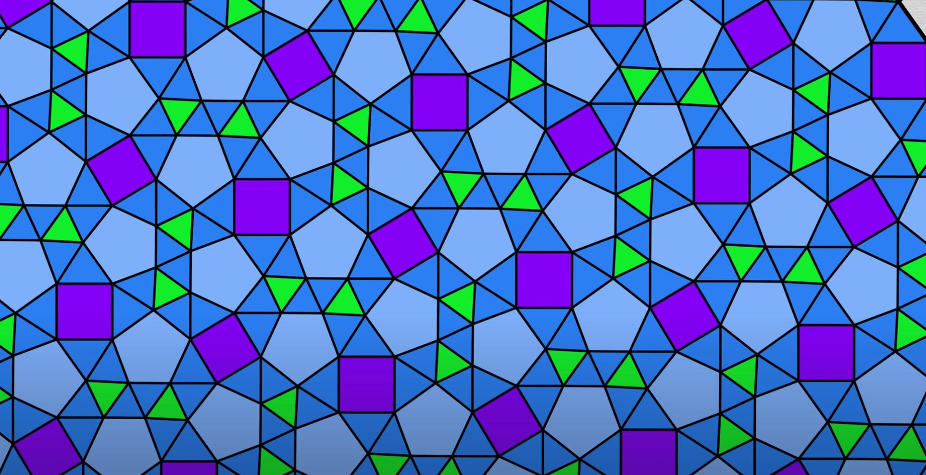
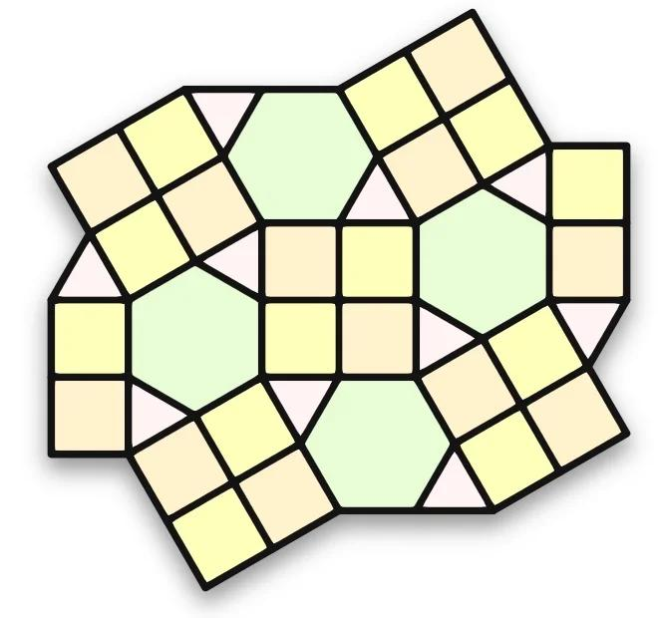

Definition
# Source: AI Source: Provided by: [Data Path: Persons Table -> ID Column: 1, Name_En Column: Motasem Essam] -> From: [ChatGPT] on [7/25/2026]
A Mixed-Polygon Tessellation is a tessellation that uses two or more different types of polygons to cover the plane completely, without gaps or overlaps.
For your Irregular Tessellations classification, the more precise meaning is a tessellation containing multiple polygon types with at least one irregular polygon type or a non-uniform arrangement.
$$\boxed{\text{Mixed-Polygon Tessellation}=\text{Multiple Polygon Types}}$$
For example, a pattern may combine:
- triangles
- quadrilaterals
- pentagons
- hexagons
in one tessellation.
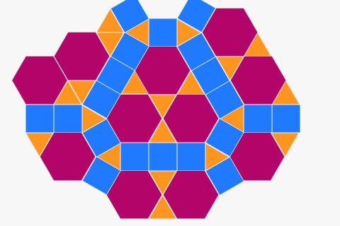
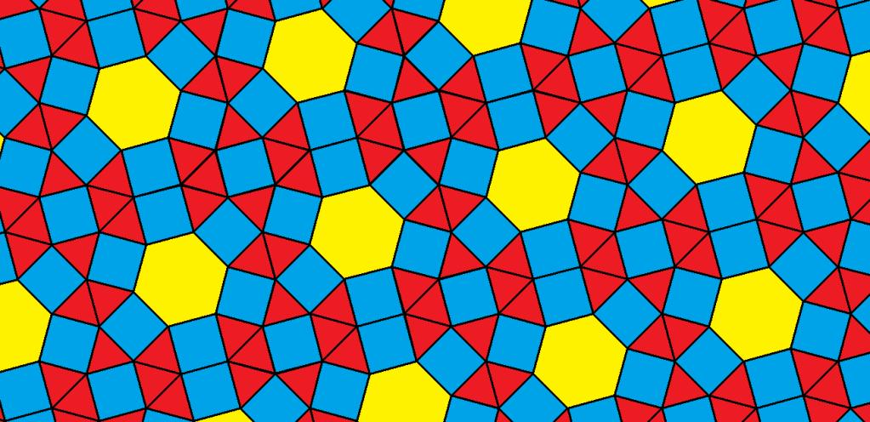
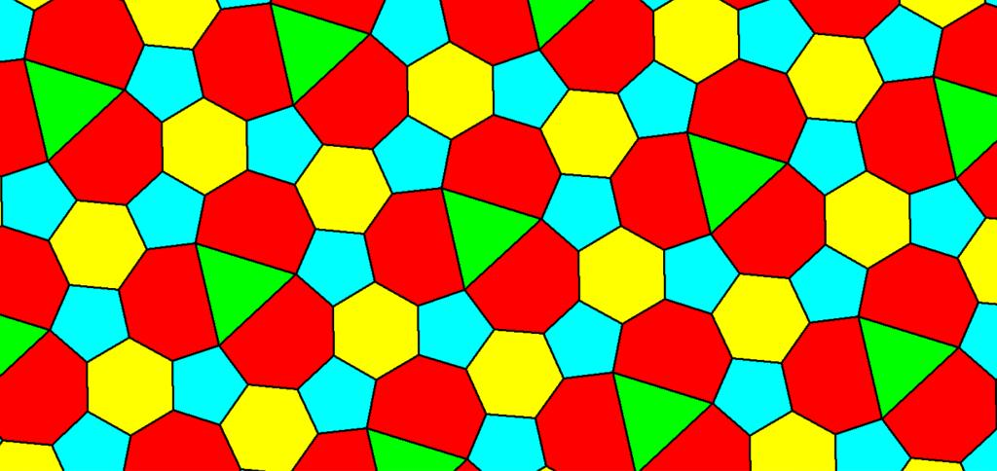
A tessellation must still satisfy the fundamental condition:
$$\boxed{\text{No Gaps}+\text{No Overlaps}+\text{Complete Plane Coverage}}$$
This is the defining requirement of a tessellation.

What Does "Mixed-Polygon" Mean?
# Source: AI Source: Provided by: [Data Path: Persons Table -> ID Column: 1, Name_En Column: Motasem Essam] -> From: [ChatGPT] on [7/25/2026]
Mixed means that more than one polygon type occurs in the same tessellation.
For example:
$$\boxed{△+□+\text{\backslash pentagon}}$$
is a mixed-polygon arrangement because three different polygon types are present.
Another example:
$$\boxed{□+\text{\backslash hexagon}}$$
contains two polygon types.
However, there is an important classification issue.

Important Classification Distinction
# Source: AI Source: Provided by: [Data Path: Persons Table -> ID Column: 1, Name_En Column: Motasem Essam] -> From: [ChatGPT] on [7/25/2026]
Mixed-polygon does not automatically mean irregular.
For example, the 4.8.8 tessellation contains:
- regular squares
- regular octagons
Therefore it is a mixed-polygon tessellation in the broad sense, but it is classified as semi-regular, because it uses regular polygons and has the same vertex arrangement throughout. (Mathwords)
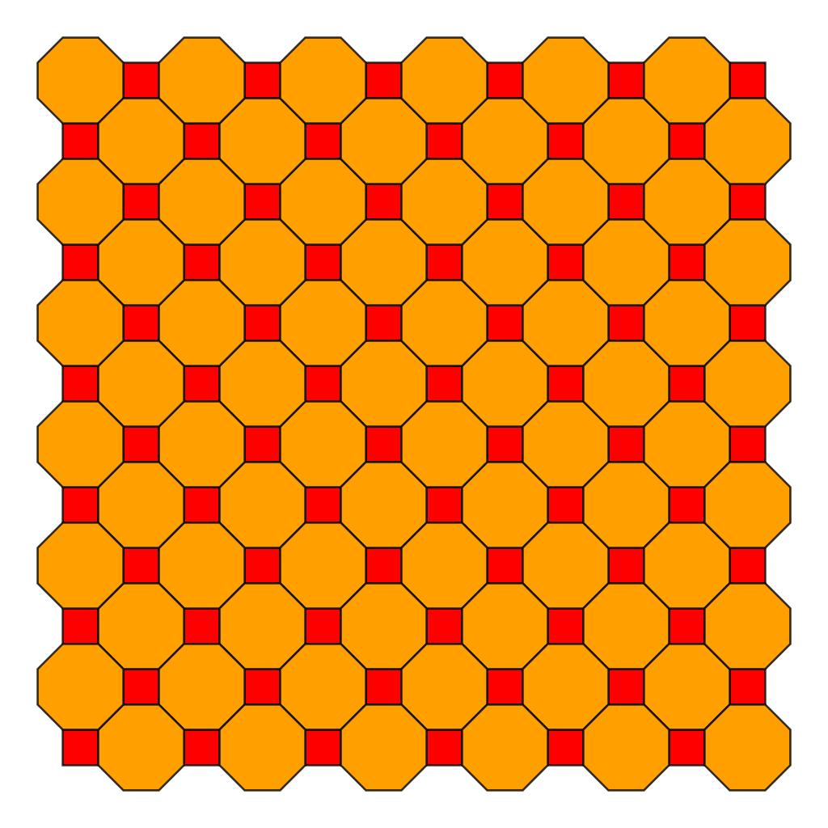
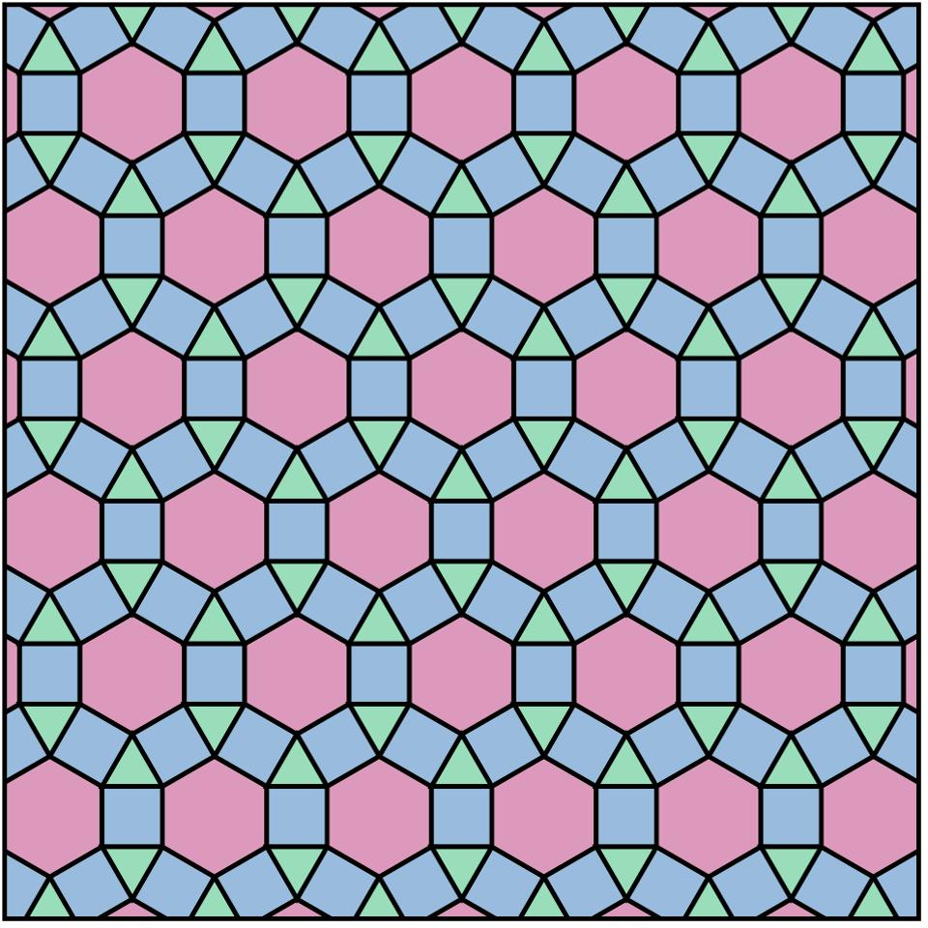
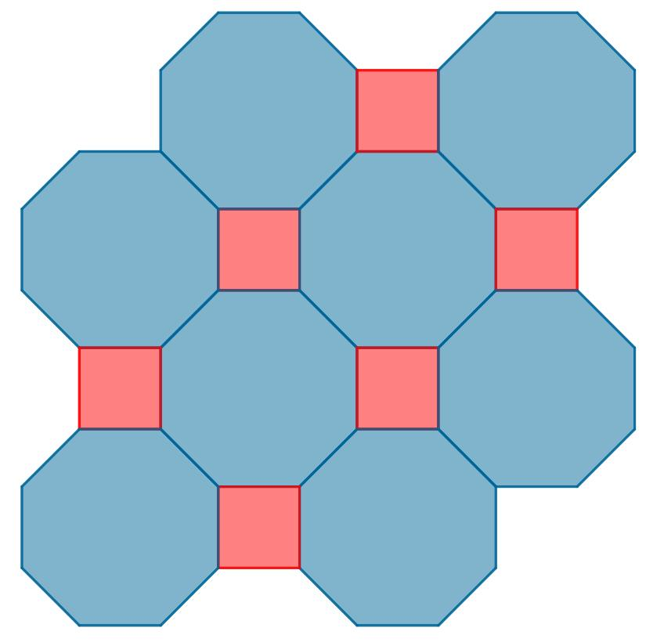
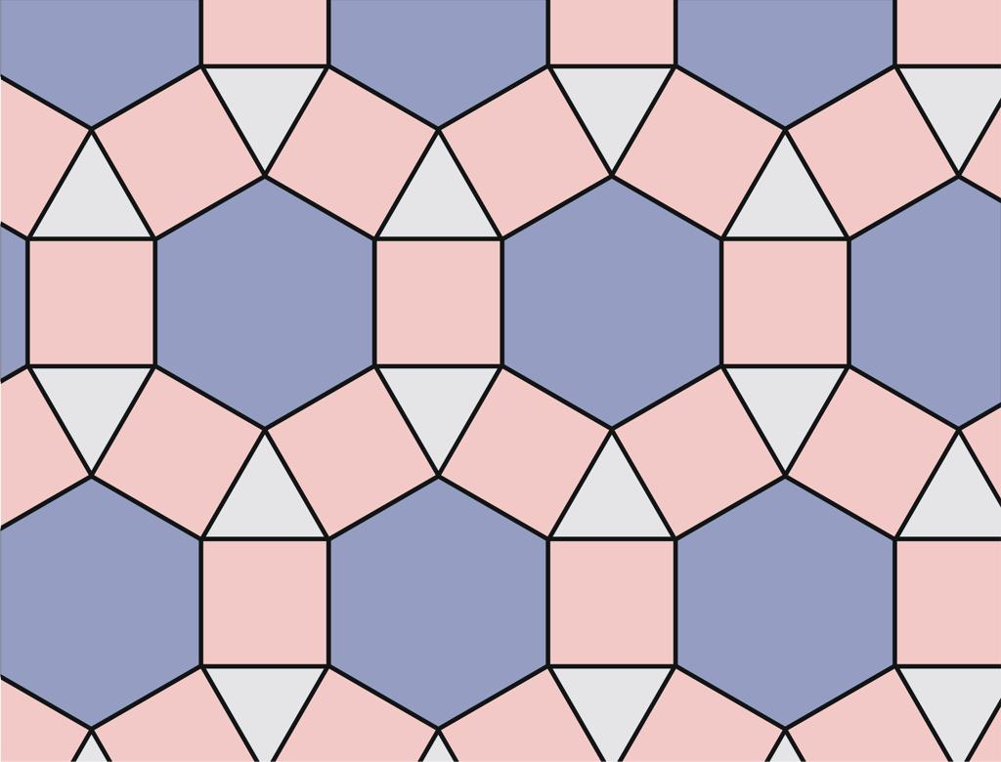
Therefore:
$$\boxed{\text{Mixed-Polygon}≠\text{Irregular}}$$
Mixed-polygon describes the number/types of polygons, while irregular describes another aspect of the geometry or arrangement.

Mixed-Polygon Tessellation Within Irregular Tessellations
# Source: AI Source: Provided by: [Data Path: Persons Table -> ID Column: 1, Name_En Column: Motasem Essam] -> From: [ChatGPT] on [7/25/2026]
For your particular knowledge-base category:
Tessellations
→ Irregular Tessellations
→ Mixed-Polygon Tessellation
the useful definition is:
A tessellation containing multiple polygon types in which the overall tiling is irregular—for example, because one or more polygon types are irregular, or because the arrangement is not uniform from vertex to vertex.
This agrees with the broader mathematical distinction that tessellations containing irregular polygons are classified as irregular tessellations. (Cambridge University Press)

Example
# Source: AI Source: Provided by: [Data Path: Persons Table -> ID Column: 1, Name_En Column: Motasem Essam] -> From: [ChatGPT] on [7/25/2026]
Consider a tessellation containing:
- 🔺 an irregular triangle
- ◼️ a square
- ⬟ an irregular pentagon
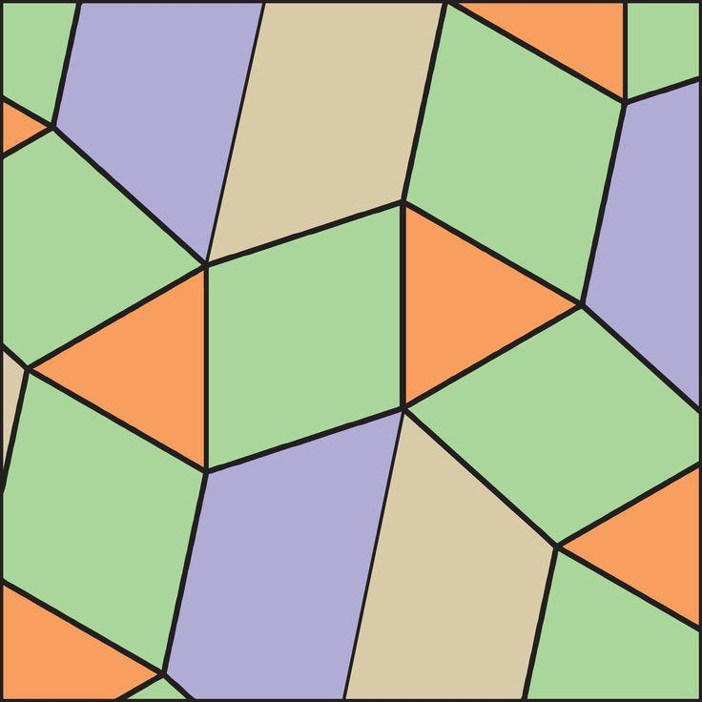
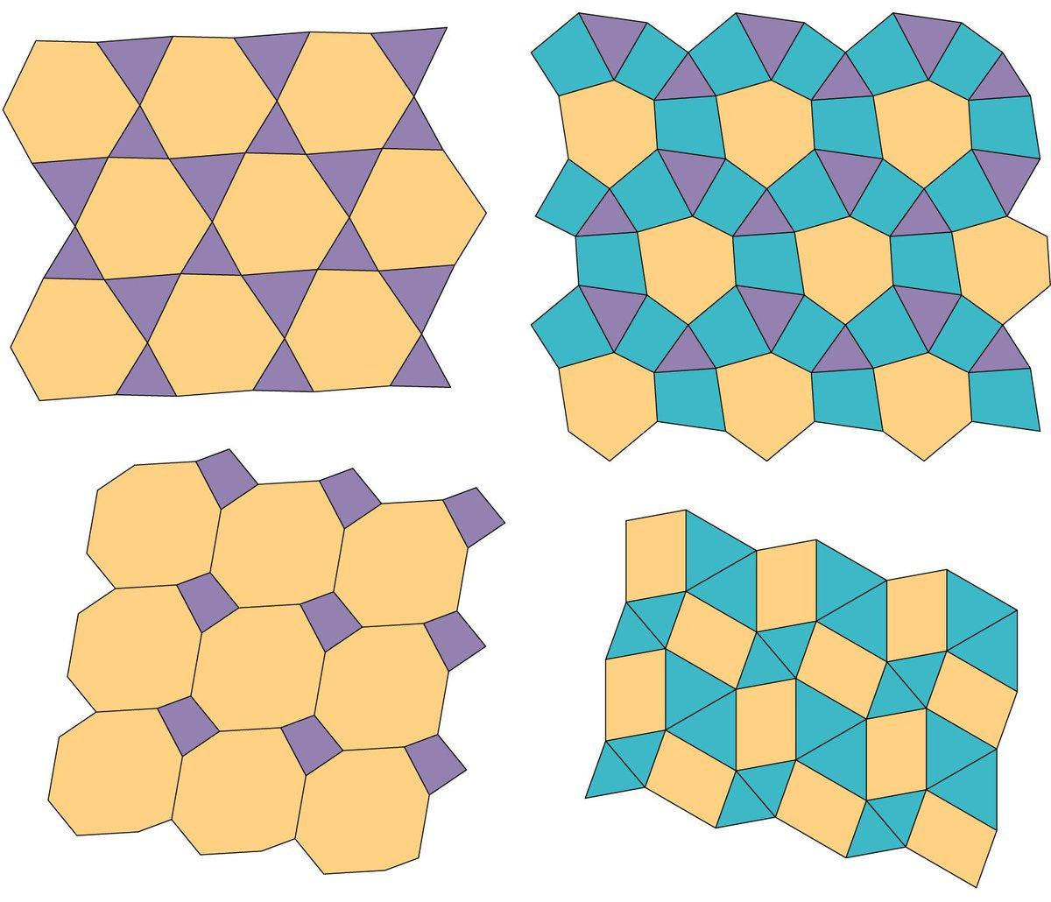
This is a mixed-polygon tessellation because several polygon types are present.
It is also suitable for the irregular tessellation category because the polygon set contains irregular polygons.

Another Example: Irregular Pentagon + Square
# Source: AI Source: Provided by: [Data Path: Persons Table -> ID Column: 1, Name_En Column: Motasem Essam] -> From: [ChatGPT] on [7/25/2026]
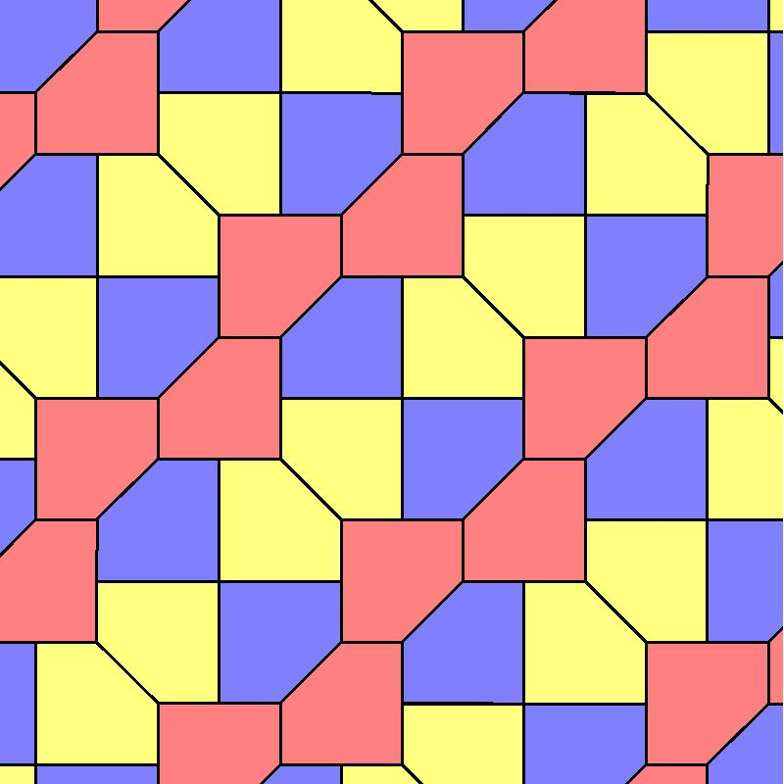
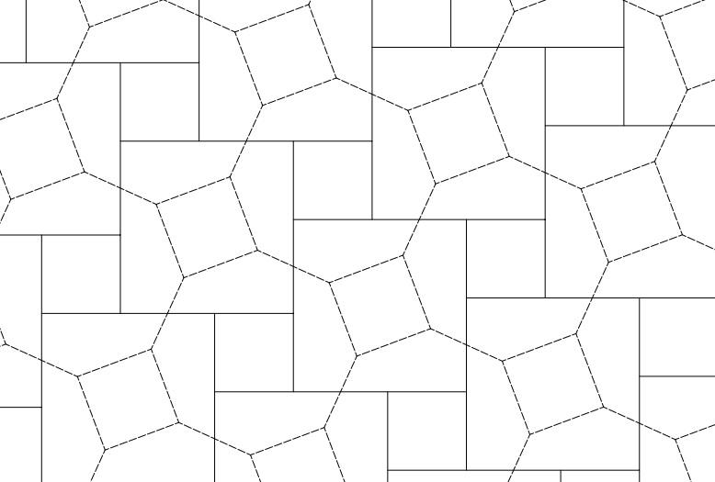
Here the tessellation combines:
$$\boxed{\text{Irregular Pentagon}+\text{Square}}$$
The square is regular, while the pentagon is irregular.
This is therefore a good example of a mixed regular–irregular polygon tessellation.

Mixed-Polygon vs Multi-Tile Tessellation
# Source: AI Source: Provided by: [Data Path: Persons Table -> ID Column: 1, Name_En Column: Motasem Essam] -> From: [ChatGPT] on [7/25/2026]
These two concepts are very closely related, so your taxonomy should distinguish them carefully.
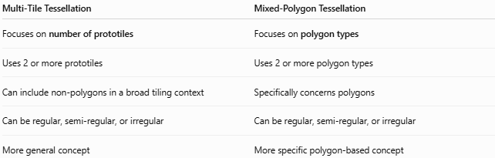
Multi-Tile Tessellation | Mixed-Polygon Tessellation
Focuses on number of prototiles | Focuses on polygon types
Uses 2 or more prototiles | Uses 2 or more polygon types
Can include non-polygons in a broad tiling context | Specifically concerns polygons
Can be regular, semi-regular, or irregular | Can be regular, semi-regular, or irregular
More general concept | More specific polygon-based concept
For example:
$$\boxed{\text{Square}+\text{Octagon}}$$
is both:
- a multi-tile tessellation, and
- a mixed-polygon tessellation,
but it is semi-regular, not irregular.

Mixed-Polygon vs Irregular Polygon Tessellation
# Source: AI Source: Provided by: [Data Path: Persons Table -> ID Column: 1, Name_En Column: Motasem Essam] -> From: [ChatGPT] on [7/25/2026]
These are also related but not identical.
Irregular Polygon Tessellation
Focus:
$$\boxed{\text{Irregularity of the polygons}}$$
It can use one or multiple polygon types.
Mixed-Polygon Tessellation
Focus:
$$\boxed{\text{Multiple polygon types}}$$
It may contain regular polygons, irregular polygons, or both.
Therefore:
$$\boxed{\text{Irregular Polygon Tessellation}≠\text{Mixed-Polygon Tessellation}}$$
but they can overlap.

Relationship Between the Categories
# Source: AI Source: Provided by: [Data Path: Persons Table -> ID Column: 1, Name_En Column: Motasem Essam] -> From: [ChatGPT] on [7/25/2026]
A useful way to organize your knowledge base is:
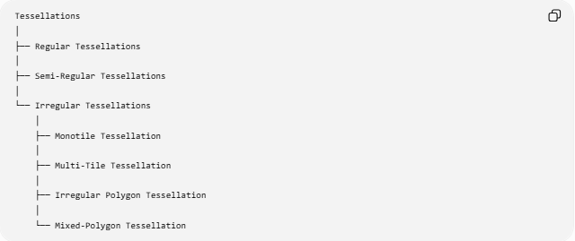
Tessellations
│
├── Regular Tessellations
│
├── Semi-Regular Tessellations
│
└── Irregular Tessellations
│
├── Monotile Tessellation
│
├── Multi-Tile Tessellation
│
├── Irregular Polygon Tessellation
│
└── Mixed-Polygon Tessellation
But there is an important structural point:
These four should not be treated as completely mutually exclusive mathematical categories.
For example, one tessellation can simultaneously be:
$$\boxed{\text{Irregular}+\text{Multi-Tile}+\text{Mixed-Polygon}}$$
because these labels describe different characteristics.

Vertex Arrangement
# Source: AI Source: Provided by: [Data Path: Persons Table -> ID Column: 1, Name_En Column: Motasem Essam] -> From: [ChatGPT] on [7/25/2026]
In a mixed-polygon tessellation, different polygons may meet at a vertex.
For example:
$$\boxed{3.4.5}$$
could describe a vertex where a triangle, quadrilateral, and pentagon meet if their angles and edges actually fit.
However, unlike the standard Archimedean tessellations, an irregular mixed-polygon tessellation does not necessarily have the same vertex configuration everywhere.
For a semi-regular tessellation:
$$\boxed{\text{Same vertex arrangement everywhere}}$$
For an irregular mixed-polygon tessellation:
$$\boxed{\text{Vertex arrangements may vary}}$$
This difference is important. (Mathwords)

Properties
# Source: AI Source: Provided by: [Data Path: Persons Table -> ID Column: 1, Name_En Column: Motasem Essam] -> From: [ChatGPT] on [7/25/2026]
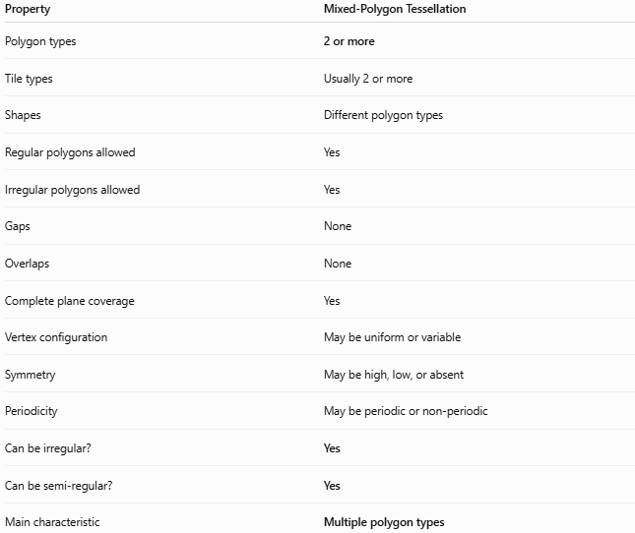
Property | Mixed-Polygon Tessellation
Polygon types | 2 or more
Tile types | Usually 2 or more
Shapes | Different polygon types
Regular polygons allowed | Yes
Irregular polygons allowed | Yes
Gaps | None
Overlaps | None
Complete plane coverage | Yes
Vertex configuration | May be uniform or variable
Symmetry | May be high, low, or absent
Periodicity | May be periodic or non-periodic
Can be irregular? | Yes
Can be semi-regular? | Yes
Main characteristic | Multiple polygon types

Example Comparison
# Source: AI Source: Provided by: [Data Path: Persons Table -> ID Column: 1, Name_En Column: Motasem Essam] -> From: [ChatGPT] on [7/25/2026]
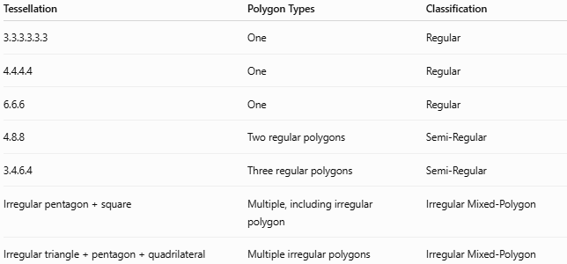
Tessellation | Polygon Types | Classification
3.3.3.3.3.3 | One | Regular
4.4.4.4 | One | Regular
6.6.6 | One | Regular
4.8.8 | Two regular polygons | Semi-Regular
3.4.6.4 | Three regular polygons | Semi-Regular
Irregular pentagon + square | Multiple, including irregular polygon | Irregular Mixed-Polygon
Irregular triangle + pentagon + quadrilateral | Multiple irregular polygons | Irregular Mixed-Polygon
The standard semi-regular tessellations are specifically defined by using multiple regular polygons with the same arrangement at every vertex.

Key Points
# Source: AI Source: Provided by: [Data Path: Persons Table -> ID Column: 1, Name_En Column: Motasem Essam] -> From: [ChatGPT] on [7/25/2026]
- Mixed-Polygon Tessellation uses two or more polygon types.
- It covers the plane without gaps or overlaps.
- It may contain triangles, quadrilaterals, pentagons, hexagons, or other polygons.
- The polygons may be regular, irregular, or a mixture.
- Therefore, mixed-polygon does not automatically mean irregular.
- In your Irregular Tessellations category, it refers to mixed polygonal patterns that have an irregular character.
- Its vertex arrangement may be uniform or variable.
- It may be periodic or non-periodic.
- It overlaps conceptually with Multi-Tile Tessellation, but "mixed-polygon" specifically emphasizes different polygon types.
- A semi-regular tessellation such as 4.8.8 is mixed-polygon but is not irregular. (Math Is Fun)

Conclusion
# Source: AI Source: Provided by: [Data Path: Persons Table -> ID Column: 1, Name_En Column: Motasem Essam] -> From: [ChatGPT] on [7/25/2026]
$$\boxed{\text{Mixed-Polygon Tessellation}=\text{Tessellation containing 2 or more polygon types}}$$
For your specific taxonomy:
$$\boxed{\text{Irregular Tessellations}→\text{Mixed-Polygon Tessellation}}$$
means a tessellation composed of multiple polygon types with an irregular overall character.
The most important distinction is:
$$\boxed{\text{Multi-Tile}=\text{multiple tile types}} \\ \boxed{\text{Mixed-Polygon}=\text{multiple polygon types}} \\ \boxed{\text{Irregular}=\text{irregular geometric character}}$$
These properties can overlap rather than forming mutually exclusive categories.

